Report by: 1409046  
Role: Level Design & Artist liaison

Game Version: Latest – with Menus  
Date Reported: 11/04/2016

QA Status: Passed

Severity: Major

Priority: Moderate

Test Introduction:

The purpose of this test was check that the lofted part of the track is correctly levelled and that all obstacles work as intended, to check this I placed the ship model onto the raised part of the map and played from there

Expected outcome:

I expected the ship to swiftly move towards then end goal without any sudden stops or jumps

Actual outcome:

When I loaded the game everything was running smoothly until I got to the extension of the raised section, here the front of the ship lifted up and bounced until it reached the end of the section.

Screenshot of the bug:

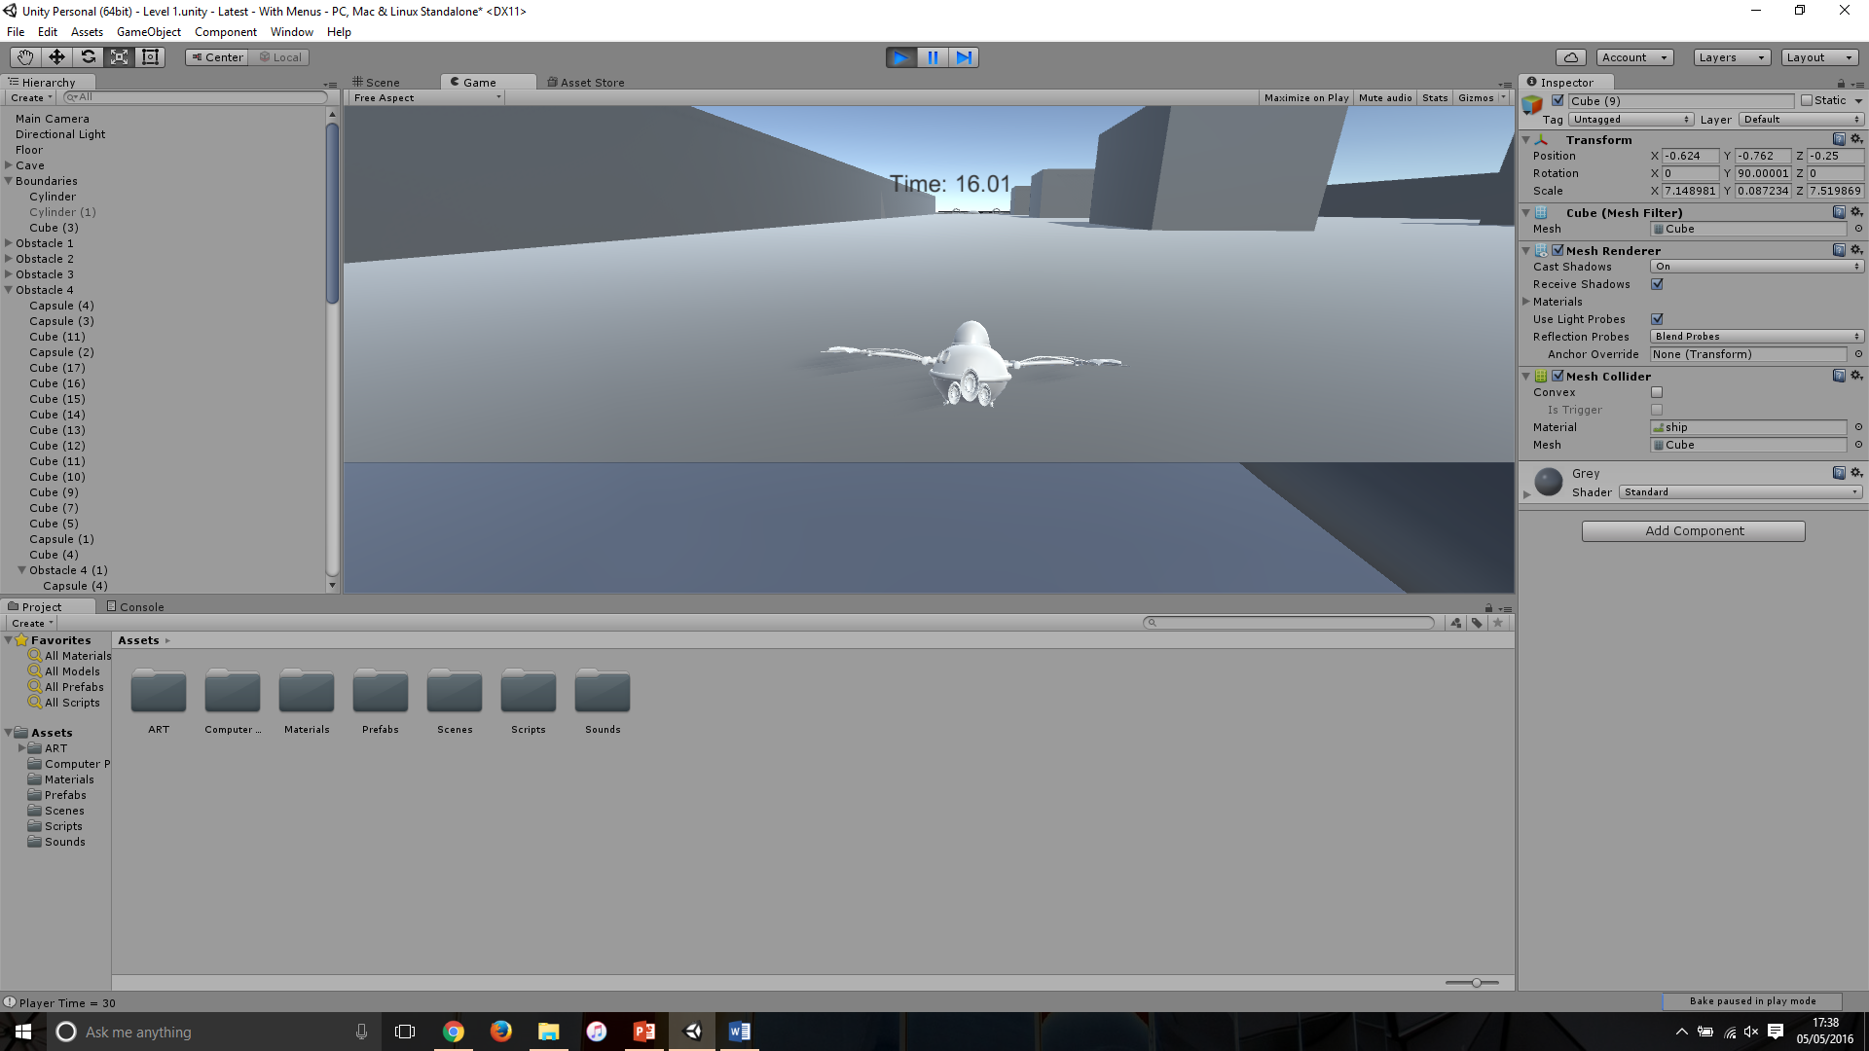

Image showing the ship ‘bouncing’ along raised section

Potential cause:

The cause for this bug was there was a slight difference in Y positions, meaning when the front of the ship went over it the collider shot up and the gravity brought it down, as this was happening at such a speed it was taking the model longer to react, giving the bouncing look

Suggested Fix:

To fix this bug the Y position of the extension was raised by .0158.